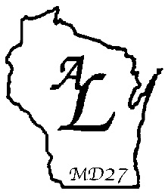

DEADLINES FOR THE CLUB SECRETARY

Note that your District may have additional deadlines established for the Club Secretary.

July 31 Monthly Project & Activity Report (P&A) form LC-01. Send copies of form to:
- Affiliate/Associate District President
- District Governor
- District Affiliate Chairman (i.e. District Liaison)
- Affiliate Area Chairperson
- Lioness Club File

August 31 Monthly Project & Activity Report (P&A) form LC-01. See above for distribution.
September 30 Monthly Project & Activity Report (P&A) form LC-01. See above for distribution.
October 31 Monthly Project & Activity Report (P&A) form LC-01. See above for distribution.
November 30 Monthly Project & Activity Report (P&A) form LC-01. See above for distribution.
December 31 Monthly Project & Activity Report (P&A) form LC-01. See above for distribution.
January 30 Monthly Project & Activity Report (P&A) form LC-01. See above for distribution.
February 28 Monthly Project & Activity Report (P&A) form LC-01. See above for distribution.
March 31 Monthly Project & Activity Report (P&A) form LC-01. See above for distribution.
April 30 Monthly Project & Activity Report (P&A) form LC-01. See above for distribution.
April 1 Deadline for Club Officer Election form LC-02. Send copies of form to:
- Affiliate/Associate District President
- District Governor
- District Secretary

May 30 Monthly Project & Activity Report (P&A) form LC-01. See above for distribution.

June 30 Deadline for submission of 100% Officer award forms to the Affiliate/Associate District
President.
- 100% President (Form LC-06), completed by Secretary
- 100% Secretary (Form LC-07), completed by President
- 100% Treasurer (Form LC-38), completed by Secretary

June 30 Monthly Project & Activity Report (P&A) form LC-01. See above for distribution.

